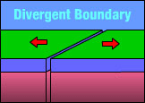

A divergent boundary is a boundary between two plates that are moving apart.
Divergent Boundaries create rift valleys and mid ocean ridges.
Rift valley: Ocean ridge:
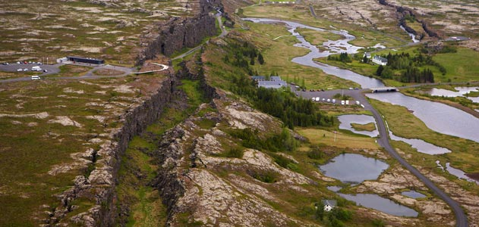
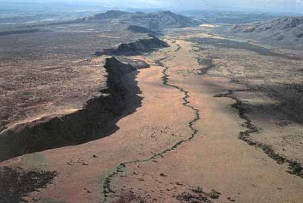
East African Rift Valley Mid Atlantic Ocean Ridge

African Plate is moving apart from itself Eurasian Plate is moving away from the North American Plate

