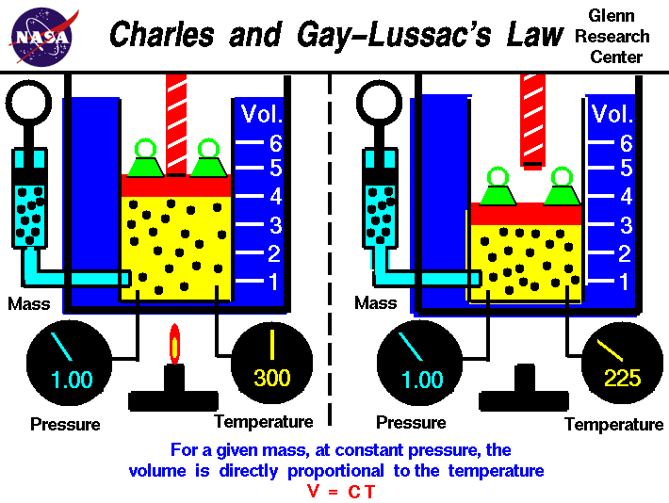
Charles Law: The volume of a fixed mass of gas is directly proportional to its Kelvin temperature if the pressure is kept constant.
Equation: V₁T₂ = V₂T_{1 (pressure is constant)} V₁ = V₂
T₁ T₂
Charles' Law is a direct mathematical relationship. This means there are two connected values and when one goes up, the other also increases. If the volume of a container is increased, the temperature increases. If the volume of a container is decreased, the temperature decreases.
The mathematical form of Charles' Law is: V ÷ T = k
EVERY TEMPERATURE USED IN A CALCULATION MUST BE IN KELVINS, NOT DEGREES CELSIUS.
The relationship between temperature and volume, at a constant number of moles and pressure, is called Charles and Gay-Lussac's Law in honor of the two French scientists who first investigated this relationship. Charles did the original work which was verified by Gay-Lussac. (Jacques Charles 1746-1823; Gay-Lussac 1778-1850).
Why? Suppose the temperature is increased. This means gas molecules will move faster and they will impact the container walls more often. This means the gas pressure inside the container will increase. The greater pressure on the inside of the container walls will push them outward, thus increasing the volume. When this happens, the gas molecules will now have farther to go, thereby lowering the number of impacts and dropping the pressure back to its constant value.

