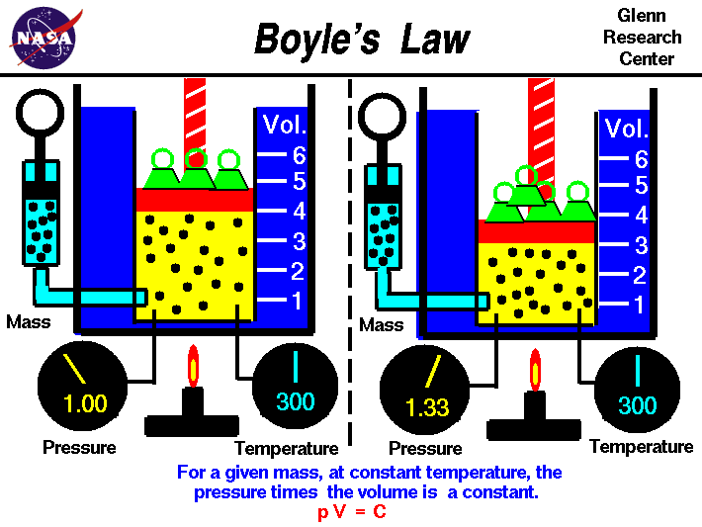
Boyle’s Law is Inversely Proportional. For a given mass, if the volume is decreased, the pressure will increase. This is shown in the graphic above with the picture on the right. Temperature must be constant.
Equation: PV=k (k is constant temperature, P is pressure, V is volume)
P₁V₁=P₂V₂
Practice Problem:
1.00 L of a gas at standard temperature & pressure is compressed to 473 mL. What is the new pressure of the gas?
P₁V₁=P₂V₂ P₁ ₌ 1.0 atm V₁=1.00 L (1000mL) V₂=473 mL
Step 1 ---- 1000 x 1 = P₂ x 473 Step 2 ---- 1000/473 = P₂ Step 3 ---- P₂ = 2.11 atm
Useful Explanation:
According to this law, the pressure exerted by a gas held at a constant temperature varies inversely with the volume of the gas. For example, if the volume is halved, the pressure is doubled; and if the volume is doubled, the pressure is halved. The reason for this effect is that a gas is made up of loosely spaced molecules moving at random. If a gas is compressed in a container, these molecules are pushed together; thus, the gas occupies less volume. The molecules, having less space in which to move, hit the walls of the container more frequently and thus exert an increased pressure.
Boyle's Law actually applies only to an ideal, theoretical gas. When real gases are compressed at a constant temperature, changes in the relationship between pressure and volume occur. However, the law is accurate enough to be useful in a number of practical applications. It is used, for example, in calculating the volume and pressure of internal-combustion engines and steam engines.
The law was first stated in 1662 by Robert Boyle. In 1676, Edme Mariotte of France independently stated the same law, and it is sometimes called Mariotte's Law.
Useful Video Link: http://video.mit.edu/watch/boyles-law-pressure-vs-volume-8456/

